**horizontal line**

**Software Project Management Plan**

Samantha TU Designs

Joseph Breen

**─**

**Table of Contents**

1. Introduction…………………………………………………………………………………… 3  
 1.1 Project Overview …………………………………………………………………. 3

1.2 Project Deliverables …………………………………………………………….... 3

1.3 Evolution of the SPMP …………………………………………………………... 3

2. Project Organization……………………………………………………………………...4  
 2.1 Process Model …………………………………………………………………..4  
 2.2 Organizational Structure ………………………………………………………..4  
 2.3 Organizational Interfaces ……………………………………………………….4  
 2.4 Project Responsibilities …………………………………………………………4

3. Management Process ……………………………………………………………………….5  
 3.1 Management Objective and Priorities …………………………………………..5  
 3.2 Assumptions, Dependencies, and Constraints ………………………………….5  
 3.3 Risk Management ………………………………………………………………5  
 3.5 Monitoring and Controlling Mechanisms ………………………………………5

3.4 Staffing Plan …………………………………………………………………....5

4. Technical Process ……………………………………………………………………….6  
 4.1 Methods, Tools, Techniques …………………………………………..6  
 4.2 Software Documentation………………………………….7  
 4.3 Project Support Functions ………………………………………………………………7  
5. Work Breakdown Structure ………………………………………………………………………. 8

# **Part I: Introduction**

## 1.1 Project Overview

Create a website that showcases and displays my Girlfriends art. Additionally this will allow her to communicate with potential clients and organizations around campus to create personalized pieces such as shirts and stickers designs. Users of the site can contact her through a form page, and she can send out calendar invites with a touch of a button.

1.2 Project Deliverables

Create a site that shows all the following:

* Current Projects and past works
* Testimonials when available
* An in depth about her section
* Form page to contact her for commissioned works

1.3 Evolution of the SPMP

As this is a living document there will be changes added as the project progresses.

Some of the features that are needed to be added are an accurate timeline of due dates and changes when they occur. Secondly the addition of sections if there are features added to the final product.

# **Part II: Project Organization**

## 2.1 Process Model

After a brief research phase I have chosen the agile method for the software

development process as I feel it will allow me to work at my own pace and keep my

client in the consent loop. After each milestone I meet with my client in order to

touch base on the direction of the site and what will be tackled next.

2.2 Organizational Structure

As I am the sole contributor on this project, I will be developing all of the software and documentation of the website.

I will be using the agile method for the development of this project. As I am the sole contributor it will be easy to prototype and communicate with the client to make changes and get the site off the ground. Once I have all the preplanning done I can move fluidly throughout the development process.

Below is a rough timeline of the remaining weeks:

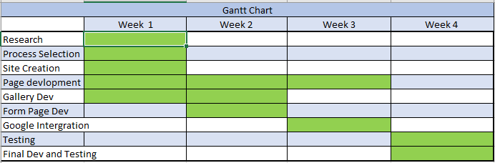

2.3 Organizational Interface

Will be using a google api for the calendar invites.

2.4 Project Responsibilities

Joseph Breen - Project Manager

# **Part III: Management Process**

## 3.1 The Management Objectives

The Objective of this project is to get a space on the web for my client to market herself. She would like to do this as cheaply as possible and thus that is the main factor in making all major decisions for this project.

## 3.2 Assumptions, Dependencies and Constraints

At the time of this document there is a global crisis and thus my client has been affected and therefore is on an extremely tight budget. Additionally, as this is a class project it must be completed within the allotted time frame.

## 3.3 Risk Management

The Biggest Risk at this time is the possibility of getting sick in the current global pandemic as that would not allow the continuation of this project. Although this is an outside factor not directly related to this course, I deemed it necessary to say as it would be stated in a real project. Besides that, the other risks are going over budget and running over time.

## 3.4 Monitoring and Controlling for Reporting

As am the sole developer on this project I will be doing all of this.

## 3.5 Staffing Plan

I will be the only person on the staff

# **Part IV: Technical Process**

## 4.1 Methods, Tools and Techniques

Methods:

1. WordPress.org

Tools:

1. Wordpress.org
2. Google API

Techniques:

1. Create a gallery that the viewer can zoom and inspect the art in detail
2. The integration of a google API

## 

## 

## 

## 

## 

## 

## 

## 

## 

## 

## 

## 4.2 Software Documentation

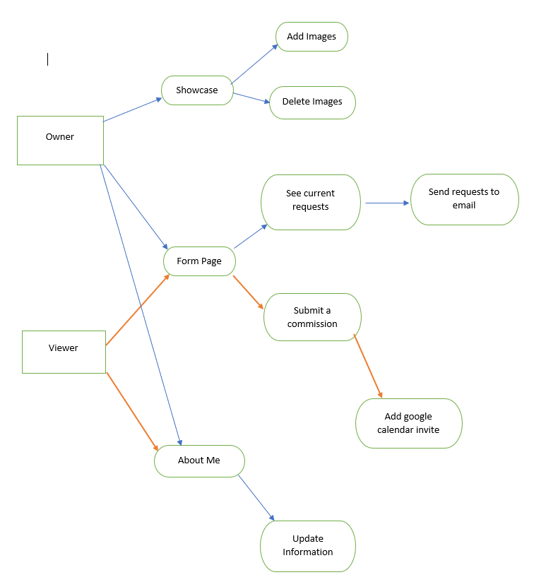

## 4.3 Project Support Functions

# **Part V: Work Breakdown Structure**